**Improving quality of living of women farmers**

**NETICA (Bayesian Nets)**

Applied Artificial Intelligence

(CS 514)



A PROJECT REPORT BY

Sai Sravith Reddy Marri (UIN: 671264014)

**INTRODUCTION:**

The women in small scale farming have many issues that they have to deal with, ranging from household issues and problems related to crop and livestock production to gender related issues and labour use of the rural women .Vietnam is not only one of the poorest countries in South East Asia, but there is much evidence of the hardship and low quality of life of these women. Constraints were found to be more than just the lack of production implements and work pressure. Low income levels, poor and unstable market access, a lack of knowledge and skills and ineffective government support are all playing a negative role in the lives of these people. The rural poor women have to face many challenges such as crop and livestock losses as the results of natural disasters, health problems that induce healthcare expenses and labour efficiency, negative debt cycles, and fluctuating and declining prices of agricultural produces; whereas agricultural insurance for production losses by the government was found the least developed service amongst other. The benefits to the rural poor from income diversification and rural industrialisation by the government for both agricultural and non-agricultural activities remain controversial since this group, with limited resources, literacy levels and thus being excluded from extension services, and poor access to credit, is very often disinclined to start new and risky businesses. The many factors involved in determining the quality of life of women and their interactions with each other make the system they are operating in very complex.

The quality of life is primarily identified to be dependent on 3 factors: Income, Health and work pressure.

**Income:**

Improved market access, reduced production costs, high product prices and more secondary job opportunities are linked to income. To solve market issues, various factors seem to be interlinked, such as external support from both the government and companies to stabilise market access. The farmers need to produce quality products and satisfy customers in terms of product types, quantity, quality and uniformity, before higher margins could be expected. In doing so, the model indicates that forming new or strengthening existing local producer groups and adopting eco-friendly practices will be required. The systems model suggests that the higher the income of the women, the more family support and work sharing could be expected. This will lead to more time for social and income generation activities for the women, which will have a positive effect on their social status.

**Work Pressure:**

Product efficiency/Infrastructure, work sharing/family support have been identified as primary factors affecting the work pressure for the small hold women.

Enhanced knowledge and skills have been reported to be one of the contributing factors for improved production efficiency, low literacy level and limited financial capacity exclude the poor smallholders from extension services as they are incapable of following extension advice and capital-intensive production guidelines. In the present study, production efficiency is linked to a change in cultivation practices and innovations that could result from improved knowledge and skills. Enhanced knowledge and skills that are linked to (could bring about) efficient and effective production. Training, its quality and coupled with on-farm practices, were preferred by the women farmers. The more knowledge and skills being obtained, the higher the demand will become in terms of the quality and nature of the training and technology transfer programs. Due to limited knowledge, local farmer union branches requested mostly very general training contents. This caused major difficulties for the extension centre to design appropriate and targeted training for the farmers.

**Health:**

Health was found to be one of the major factors that influences the system in which the women farmers operate. This influence is mainly through its effect on production efficiency and via the linkages with access to healthcare service, rural hygiene and eco-friendly production practices. Determinants of the health of the women were found to include access to healthcare, agro-chemical use, work pressure and rural hygiene. Enhancing eco-friendly practices together with quality control will lead to a high probability that chemical use will be reduced, and thus doubled the probability of good health. Access to healthcare services and reduced work pressure have rather similar effects on health. Rural hygiene was found the least influential factor with only a small chance of improving health conditions. The aggregated interventions by all five determinants will result in a high probability that the target group will be in good health.

Income (affected by factors such as market access, production costs etc.) was identified as the second leverage in the system that affects the system as a whole, while work pressure (linked to production devices, capacity building) was identified as the third leverage in the system. Interestingly, but as could be expected all these leverages and the factors that affect them are intrinsically interlinked, which is the main reason why the three leverages were included in one Bayesian Belief Network (BBN) model to determine the systemic interventions . Because all three these leverages directly affect the quality of life of the women farmers, making this the main goal provided an opportunity to combine the three BBNs into one.

**Test Cases:**

**Testcase 1:**

Decision based on original beliefs and prior probabilities.Initially filled data from the reference papers study of the contributing factors that affect the quality of life of women in rural small-scale agriculture.

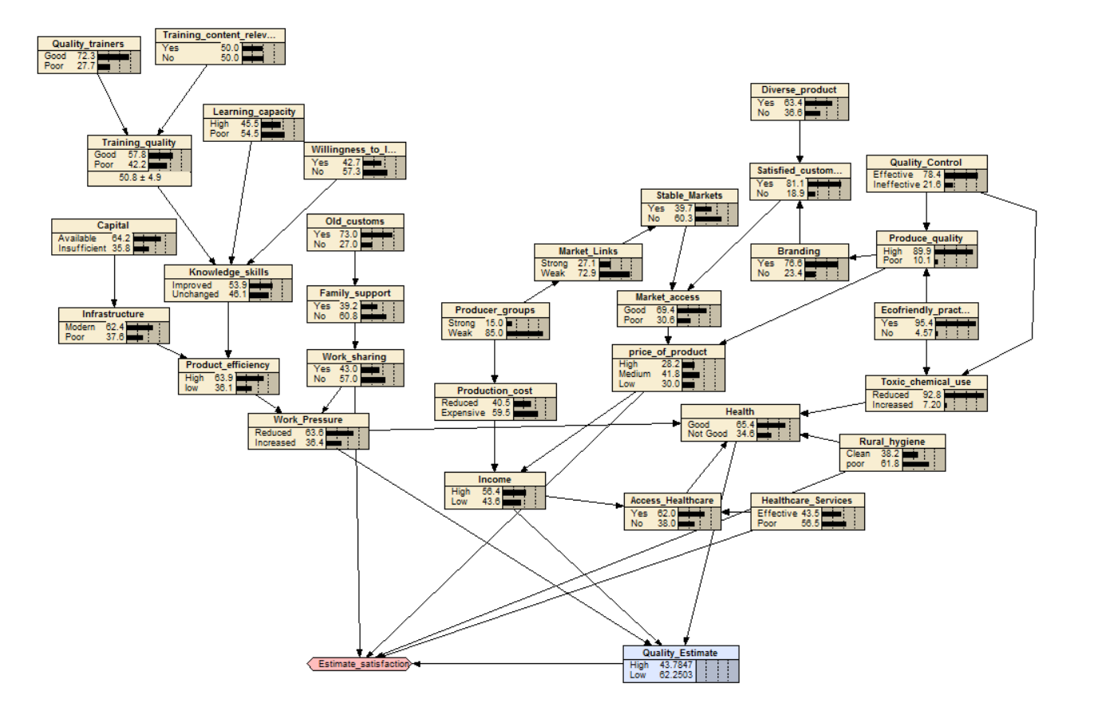

**Testcase 2:**

Wok sharing, better selling price, and good rural hygiene and heath care leads to the best estimate for it being High.

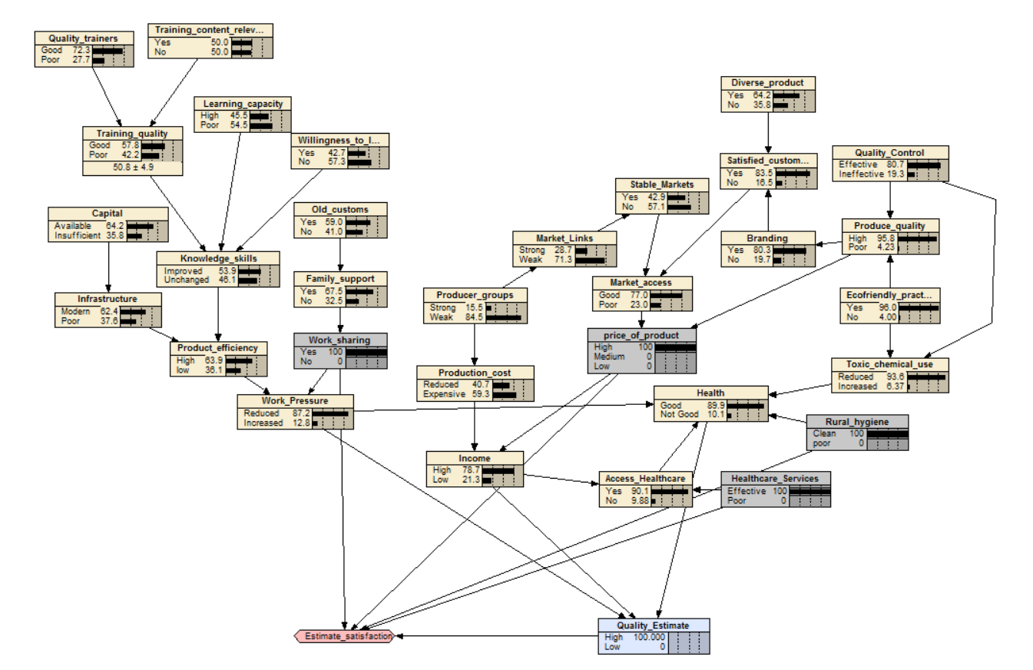

**Testcase 3:** Poor quality of trainers, poor willingness to learn, and old customs leads to low knowledge skills. This along with low capital leads to increased word pressure. Ineffective quality control of products, poor rural hygiene and healthcare services lead to poor health. These factors contribute to poor quality of life as we can see in the figure.

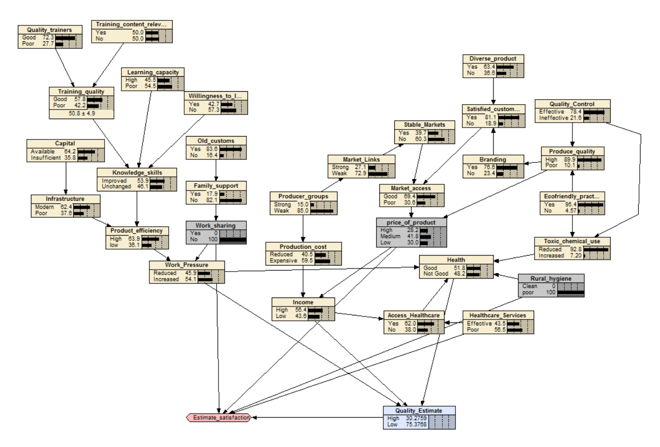

**Testcase4:** The decision estimate is relatively low when there is no work sharing, and poor rural Hygiene

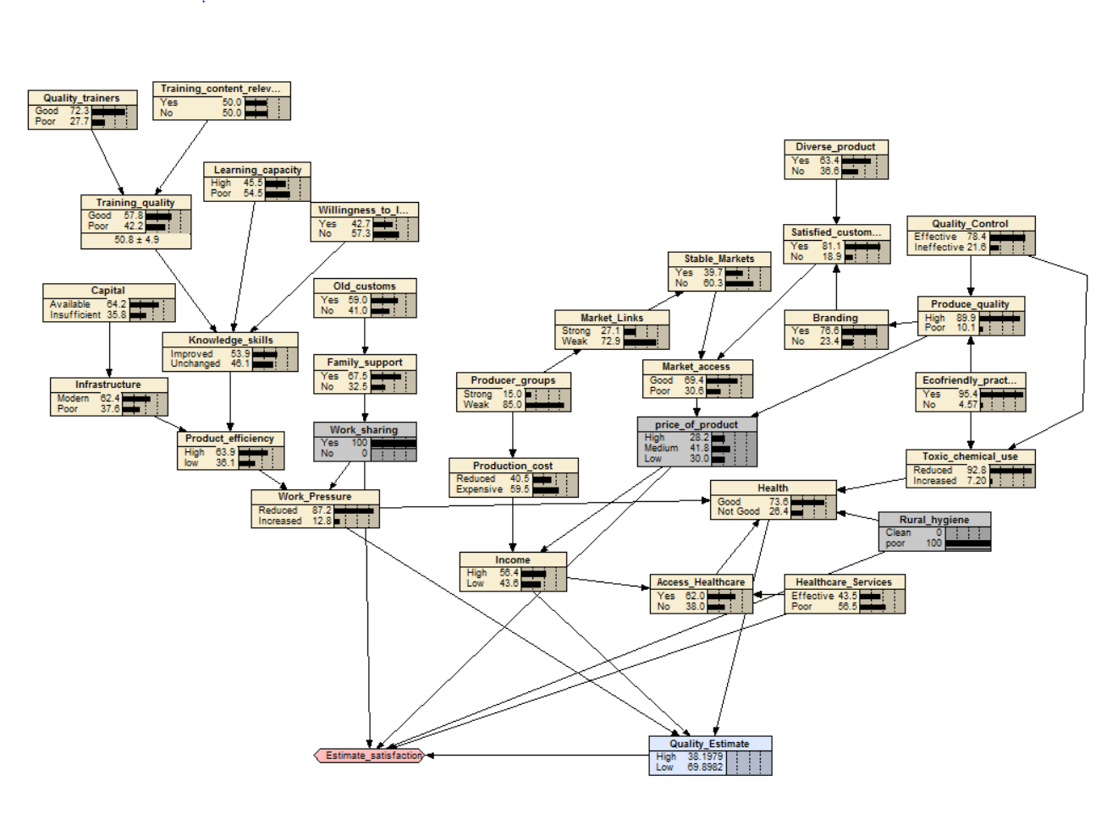

**References:**

* Starkey P. 2002. Improving rural mobility: options for developing motorized and nonmotorized transport in rural areas. World Bank Publications.
* Tisdell CA. 2009. The survival of small-scale agricultural producers in Asia, particularly Vietnam: General issues illustrated by Vietnam's agricultural sector, especially its pig production, University of Queensland, School of Economics.
* Tran M. 2009. Food security and sustainable agriculture in Vietnam. In Country report. The fourth session of the technical committee of APCAEM. . Vietnam Institute of Agricultural Engineering and Postharvest Technology.